Dokumentimi I detyrave te shtepise.

# Kapitulli 1

# Introduction to Programming

Prof:Muzafer Shala

Ass:Laberion Zebica Student:Elion Krasniqi

Kampusi:FERIZAJ

1. Install and make yourself familiar with **Microsoft Visual Studio** and Microsoft Developer Network (**MSDN**) Library Documentation.
2. If you have a **DreamSpark account** ([www.dreamspark.com](http://www.dreamspark.com/)), or your school or university offers free access to Microsoft products, install the full version of **Microsoft Visual Studio**. If you do not have the opportunity to work with the full version of Microsoft Visual Studio, you can download **Visual Studio Express** for free from the Microsoft web site; it is completely free and works well for learning purposes.
3. Find the description of the **System.Console** class in the standard .NET API documentation (MSDN Library).

2.    Use the address given in the "[**.NET Documentation**](https://introprogramming.info/english-intro-csharp-book/read-online/chapter-1-introduction-to-programming/#_.NET_Documentation)" section of this chapter. Open it and search in the tree on the left side. A **Google search** will work just as well and is often the fastest way to find documentation for a given .NET class.

1. Find the description of the **System.Console.WriteLine()** method and its different possible parameters in the MSDN Library.

3.Writes the specified data, followed by the current line terminator, to the standard output stream.

1. **Compile and execute** the sample program from this chapter using the command prompt (the console) and Visual Studio.

using System;

namespace detyra8

{

class Program

{

static void Main(string[] args)

{

Console.WriteLine("Hello World!");

}

}

}

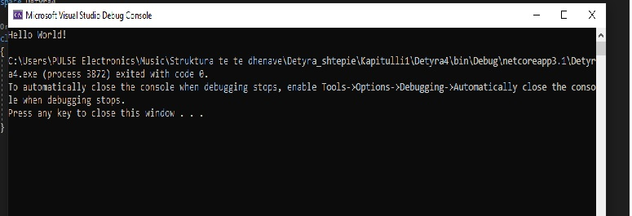

**5.Modify** the sample program to print a different greeting, for example "Good Day!".

using System;

namespace detyra5

{

class Program

{

static void Main(string[] args)

{

Console.WriteLine("Good Day!");

}

}

}

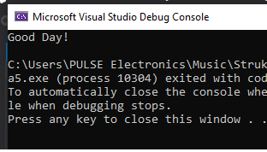

6.Write a console application that **prints your first and last name** on the console.

using System;

namespace detyra6

{

class Program

{

static void Main(string[] args)

{

Console.WriteLine("Albion\nBurrniku");

}

}}

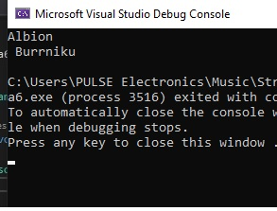

7.Write a program that **prints the following numbers** on the console 1, 101, 1001, each on a new line.

using System;

namespace detyra7

{

class Program

{

static void Main(string[] args)

{

Console.WriteLine("1\n101\n1001");

}

}

}

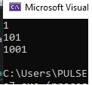

8.    Write a program that prints on the console the **current date and time**.

class detyra8

{

static void Main()

{

System.Console.WriteLine(System.DateTime.Now);

}

}

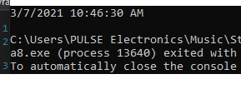

9.    Write a program that prints the **square root of 12345**.

using System;

class detyra9

{

static void Main()

{

Console.WriteLine(Math.Sqrt(12345));

}

}

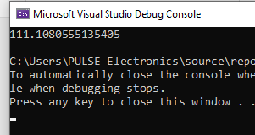

10.   Write a program that prints the first 100 members of the **sequence** 2, -3, 4, -5, 6, -7, 8.

using System;

namespace Ushtrimi10

{

class Ushtrimi10

{

static void Main(string[] args)

{

for (int i = 2; i <= 100; ++i)

{

if (i % 2 == 0)

{

Console.WriteLine(i);

}

else

{

Console.WriteLine(-i);

}

}

}

}

}

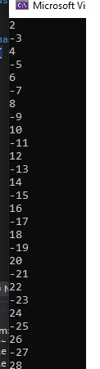………. 

11.   Write a program that reads your age from the console and prints your **age after 10 years**.

using System;

namespace detyra11

{

class Program

{

static void Main(string[] args)

{

Console.WriteLine("Shkruaj moshen tuaj");

int mosha = Convert.ToInt32(Console.ReadLine());

Console.WriteLine("Mosha juaj pas 10 viteve eshte {0}", mosha + 10);

}

}

}

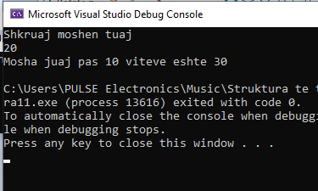

12.   Describe the difference between **C#** and the **.NET Framework**.

In simple terms, C# is a programming language, whereas .NET is the framework on which the language is built. Microsoft created .NET (Network Enabled Technology), and .NET developers will use programming languages such as C#. In fact, .NET supports many programming languages, and defines the rules and associated libraries those languages will use. The .NET framework is the management tool for a shared library of code that developers can use so that they don’t have to write code from scratch every time. .NET is packed with tens of thousands of pieces of shared code allowing developers to use common functions. As well as this, it also provides a runtime environment for applications. Other platforms (for example Java) do this too. .NET’s runtime environment is called the Common Language Runtime (CLR). What this means in practice is that an application written in a language such as C# will be able to run on any piece of hardware that supports .NET. So, if you’re a developer using C# to write the code for your app, you know it’ll be able to run on anything that supports .NET.

13.   Make a list of the **most popular programming** languages. How are they different from C#?

1. Python
2. JavaScript
3. Java
4. C#
5. C
6. C++
7. GO
8. R
9. Swift
10. PHP